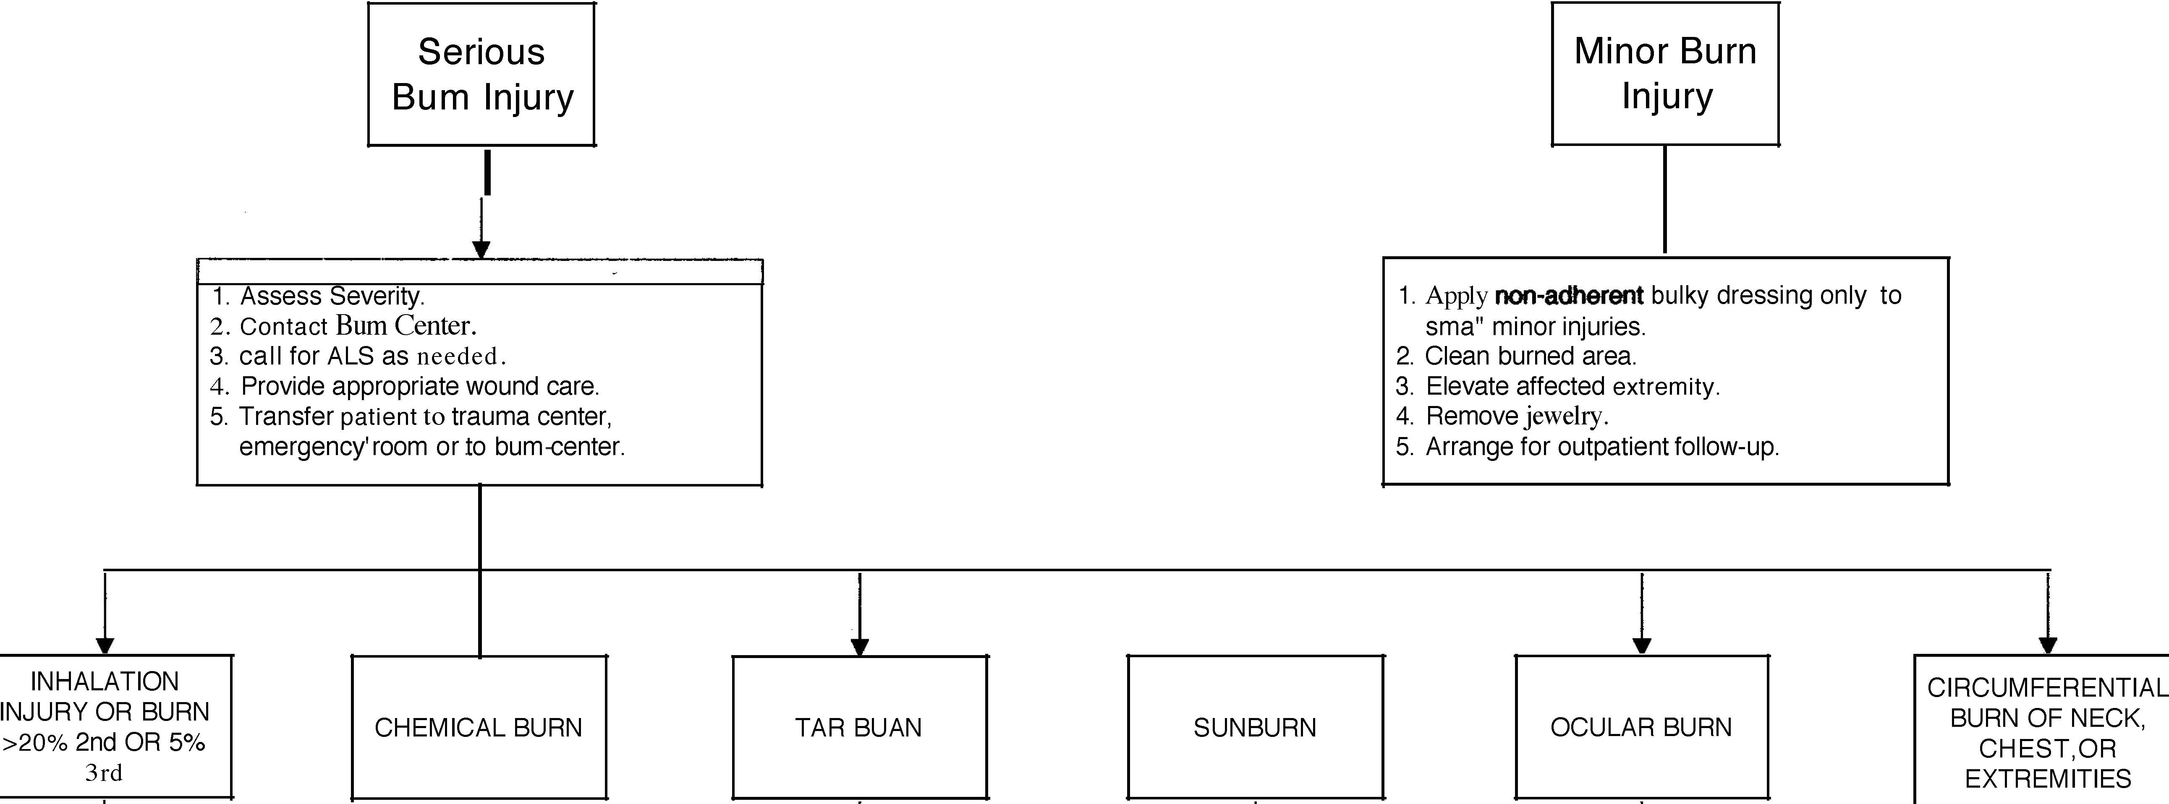



1. Standard A, B, CiS.

2. Sterile Dressings.

3. Transport to Bum Center or emergency room,'




1. Apply with saline' soaked dressings.
2. Arrange outpatient
follow-up if hospital admission is not





1. Irrigate with saline.

2. Obtain physician consultation.

3. Check for-contact lenses.

4. Patch the eye.
5. Transport to hospital emergency room.


NECK BURN:

1. Assess airway.

2. Provide respiratory support.

3. Evaluate airway frequently.

4. Transport to hospital

emergency room. CHEST BURN:'
1. Observe for signs of respiratory compromise.
2. Transport to hospital emergency room.
EXTREMnY BURN:
1. Elevate injured extremity.
2. Remove jewelry.

3. Reevaluate frequently for edema.

4. Transport-to hospital emergency room.

1-. Irrigate copiously.

2. Provide specifIC treatment for chemical exposure.

3. Transport to hospital emergency room.

1. Cool tar with water.

2. Leave tar in place.

3. Cover with sterile
dressings.
4. Transport to hospital emergency room.

